Instructions and template for PRF2022 extended abstracts
Alex J. Rinehart^{1*}, Martha Cary “Missy” Eppes^{2^}, Matthew Brain³ and Kerry Leith⁴
¹ Earth and Environmental Science Department, New Mexico Tech, Socorro, NM, USA.
² Department of Geography and Earth Sciences, University of North Carolina, Charlotte, Charlotte, NC, USA

* Corresponding author information: alex.rinehart@nmt.edu, 1-575-835-5061
^ Presenting author

Deadline
The extended abstract submission deadline is 15 March 2022.

Language
Abstracts should be submitted in American English.

Extended abstract size and naming convention
PLEASE USE THIS TEMPLATE FORMAT. Copy your text from another document and “paste special” as unformatted text to preserve the template fonts and formatting in each section. PLEASE DO NOT MODIFY FONT SIZE or TYPE, LINE SPACING, ETC, from this template. If your submitted pdf is not in this format, you will be asked to reformat and resubmit.
Using the format, your abstract should not exceed 2–4 pages including optional figures, captions and references.
Please name your file by using the first author’s surname_name (e.g. William Prager: prager_william.doc, prager_william.pdf.). Leave the abstract number empty. Figures and tables should be inserted inline.

Title and authors
Capitalize the only first word and proper nouns (names) in the title. Authors should be listed in order of contribution. A presenting/corresponding author should be indicated. The affiliation of each author should be given.

Pre-defined text styles and further instructions

Pre-defined text styles
Please use the predefined styles (Table 1).
Table 1. Predefined styles
Text element | Pre-defined Style
Abstract title | use bold Arial 16
Addresses of authors | use Arial 9
Authors | use Arial 11
Body text | use Arial 11 with 1.15 spacing
Bullet lists | use «Bullets»
Figure and table captions | use «Figure caption» and «Table caption»; Arial 10.
Reference list | use «Reference list»: Arial 9.
Section headers | use «Section header» (bold Arial 13) and «Sub-header» (italicized Arial 11)
Table text | use «Table text»

Further instructions
- Use Arial 11, 1.15 spacing, italics and scientific notations according to standard international rules.
- Margins are given by this template.
- The abstract file should be submitted in .doc or .docx (or .rtf) format and as a pdf for copy-editing special characters and formulas.
- Use automatic hyphenation.

Figures, photographs and tables
We recommend to submit drawings and photographs in pixel form (e.g. .tif, highest quality .jpg). Please make sure that you scale your illustration to printing size (maximum 24 cm x 17 cm, or 9.5 inches x 6.7 inches) with a minimum resolution of 300 dpi for photos and 600 dpi for line art. Please check that your figures and included text are readable at this size (avoid text smaller than 8pts) in Arial Narrow font.
Color photos are acceptable for the online version, but will be printed in black and white. Please use color schemes that are accessible to those who have color vision deficiency.
Text and other annotations in the figures should be in the figure file itself and not added in the Word file as text or annotation. Lines should be no smaller than 1 pt. Maps should include coordinates (m E, m N UTMZone; or °N, °E), a scale bar and north arrow. Titles should appear in the caption, not the figure itself. All axes and lines should be labeled.
For photographs, please mention the name or source of the photograph. If the figure is based on another figure, please cite the reference.
Base table formats on the example above.
Put captions directly below figures and photographs (see below) and above tables (see above). Please include all texts and annotations in the figures themselves.
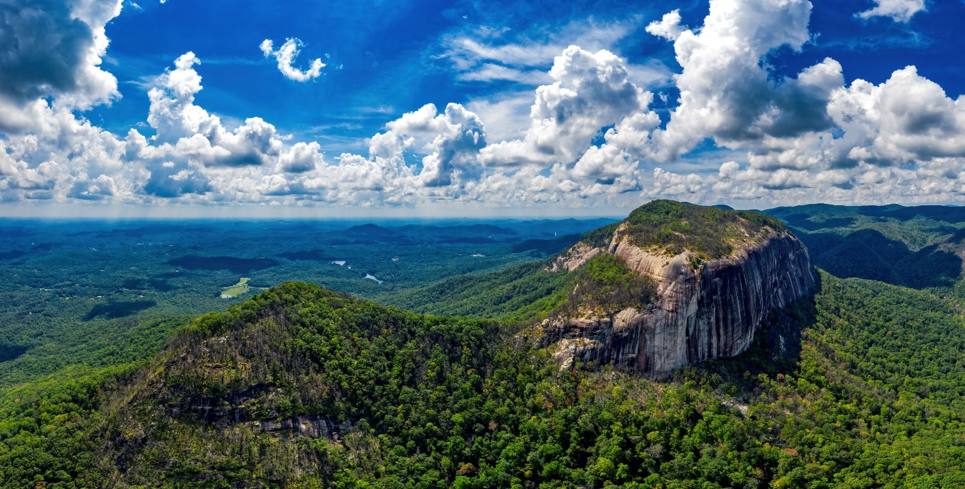
Figure 1. Photograph of Table Rock, South Carolina – in the vicinity of the PRF2022 Conference Venue in Flatrock NC. Table rock is a granitoid exfoliation dome typical of the region (photograph ©J.J. Fowler vanzeppelin.com).

Acknowledgments
Please put brief acknowledgments of funding agencies, analytical laboratories, facilities, early reviewers and others before the reference section.

References
Please put references at the end of the extended abstract text using the GSA reference style. References should be cited in the text as follows:
- Author & Author (1989) instead of Author and Author (1989)
- (Author 1989a, b; Author & Author 1987) instead of (Author, 1989a,b; Author and Author, 1987)
- (Author et al. 1989) instead of (Author, Author & Author 1989)
- Use the following style: (Author, in press); (Author, in prep.); (Author, unpubl.); (Author, pers. comm.)

Reference list
Jappelli, R, Marconi, N. 1997. Recommendations and prejudices in the realm of foundation engineering in Italy: A historical review. In Carlo Viggiani (ed.), Geotechnical engineering for the preservation of monuments and historical sites. Proc Int Symp, Napoli, 3–4 October 1996. Rotterdam: Balkema.
Terzaghi, K, Peck, RB. 1987. Soil mechanics in engineering practice, 2nd ed., McGraw Hill, New York, NY, USA.
Terzaghi, RD. 1965. Sources of error in joint surveys. Geotechnique 15, 287–304.
Vijaykumar, S, Curran, JH, Yacoub, TE. 2001. Node-centric displacement discontinuity method for plane elasticity problems. In Desai et al. (eds.), Computer Methods and Advances in Geomechanics. Proc 10th Int Conf, Tucson, 7–12 January 2001. Rotterdam: Balkema.

Publication and Embargo
GSA will publish each abstract with a citable doi through their Confex system prior to the Conference. Abstract content will only be made available to conference attendees at that time.
After a 6 month embargo period, all PRF2022 Penrose Conference abstracts will be made publicly available permanently through www.geososciety.org

